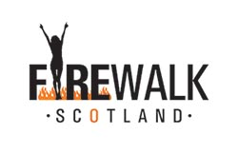
Hi there,
Firstly………. Congratulations! If you are reading this then you are about to take part, or are considering taking part in a fire walk. We understand that you may have many questions about fire walking, what happens on the night itself and of course the general health and safety of such an event. The information below should help you in making an informed decision on the way forward and reassure you that your feet are in good hands.

Fire-walking is as old as man himself, there are numerous biblical references to fire-walking, the Vikings used to walk bare-foot across red hot iron bars and the! Kung tribe of the Kalahari Desert are a fire worshipping tribe, who dance across it and rub the hot coals over their bodies.

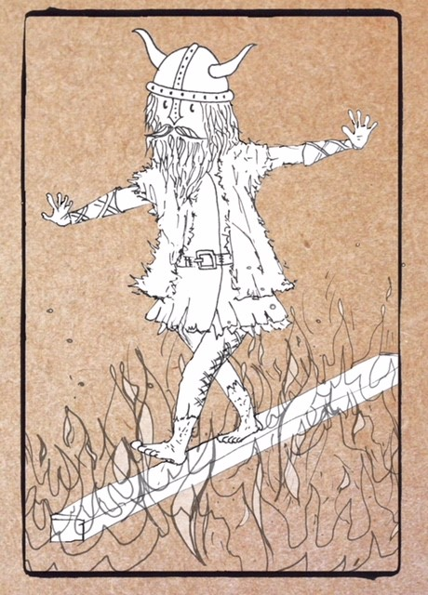

Fire-walking was ‘introduced’ to the West in the late 1970’s by Tolly Burkan, the founder of the global fire-walking movement and the Institute for fire-walking institute for research and education.(F.I.R.E.) Tolly‟s training methods are well respected throughout the world and he is generally thought of as the leader of fire-walking matters and his training methods are well respected throughout the fire-walking community. Well known graduates of his school include; Anthony Robbins and Peggy Dylan. Lee Walls founder of Firewalk Scotland, also trained with and is personally accredited by Tolly Burkan.

Firewalk Scotland has been established since 2006 and has a well-established reputation for being able to provide exciting, life changing events and courses.

“A journey of a thousand miles starts with a single step” whether your reasons for coming along are spiritual, you are fund-raising or thrill seeking we want you to have a great experience, so there are a few rules

- Participants must attend a 90 minute workshop prior to the fire-walk (otherwise how do you know what to do)
- You must not drink before or during the workshop ( we want you to have a great night being brave all by yourself, fill your boots afterwards)
- 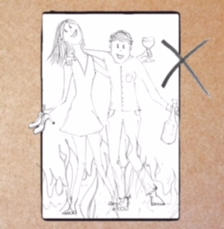

- No phones are permitted during the workshop or on the fire itself ( other people are welcome to take your photographs and again, we don’t want to be fishing phones out of a fire)

- Please don’t prepare your feet with lotions or potions, if you have nail polish on take it off three or four days in advance, don’t paint your toe nails for the event (this question gets asked a lot!)

- Fire-walking is a dirty business, so wear old clothes, shoes that come off easily and trousers that can be rolled up or shorts. We would also ask that you bring along an old towel or wipes for cleaning your feet

- Spectators can’t sit in on the workshop

That’s it, all of the rules and all in place to keep YOU safe and make sure that you and we have a great night.

On the night of your event- fire-walkers should arrive in plenty of time for the workshop which lasts around 90 minutes. When our fire-walkers arrive they will be asked to complete a disclaimer which states that they are both drug and alcohol free and that they are walking at their own risk

Spectators are NOT permitted to sit in on the workshop

After the workshop the group are then lead outside to walk across the glowing embers of the fire, the fire-walk is around five metres and can usually be covered in a few steps. At no point will anyone be forced or coerced into walking on the embers, it is entirely voluntary. We are happy for you to walk over the coals more than once if you wish.

Start to finish the event runs for around 2 hours, it is not weather dependant, if it is raining we still go ahead! Our events will only ever be postponed if there is a risk involved e.g. severe high winds. If you have any health concerns e.g. diabetes, circulation problems please do seek medical advice before the event and notify Lee at the start of the workshop.

Health & Safety is our number one priority, all of our events are insured for £2million, however the act of walking on fire is uninsurable. Although we have a proven track record for providing well managed, safe events, we always ensure there is an adequate supply of water to extinguish our fire in case of emergency and as an extra precaution we provide a fire extinguisher and fire blanket. We are well equipped for first aid and always bring a full first aid kit.

I hope that covers everything, if you have any further questions please do get in touch either by email to info@firewalkscotland.co.uk

Or by phone on:07974841957

www.firewalkscotland.co.uk

We look forward to meeting you soon!
Best foot forward,
Lee

Letter to fire-walkers updated January 2018

